

**休闲裤贴袋机**

**Chino Pocket Setter**

**（MB1002D-1-S7300A-305P）**

**使用说明书**

**Instruction Manual**

常州智谷机电科技有限公司

**在使用本设备之前请先阅读本使用说明书.**

2020.01

版本信息

**请将本使用说明书放在便于查阅的地方保管**

**感谢购买IMB工业用缝纫机。**

**在使用此机器之前，请仔细阅读以下的说明，这样可以更好地帮到您了解此机器的相关操作。**

**这些说明是根据现行的条例明确阐述了正确的工作方法。**

Thank you for purchasing this industrial sewing machine from IMB

Before using this automatic unit, please read the following instructions, which will help you to

understand how the machine operates.

These instructions illustrate the correct working methods to comply with current regulations.

**在没有得到IMB授权许可的前提下，此说明书的任何部分是不可以被复制或者转录的。**

**说明书的内容可能被修改，而不需预先通知。**

No part of this manual may be copied or transcribed without requesting prior authorization from IMB

The contents of this manual may be subject to change without advance notification.

**我们将欣然接受各位提出的改进此说明书的任何建议和指示**

We are happy to receive suggestions and/or indications on ways we could improve this manual.

**本机介绍说明分为三部分，具体请参照《MB1002D休闲裤贴袋机-使用说明书》、《MB1002D休闲裤贴袋机-零件手册》、《MB1002D休闲裤贴袋机-触摸屏界面操作说明》。**

**ENGLISH**

**Catalog**

1、Basic information of equipment - 1 -

2、Technical parameters of the equipment - 2 -

3、Safety precautions - 3 -

4、Key function description - 4 -

4.1. Function description of the button - 4 -

4.2. Reset operation instructions - 5 -

4.2.1 Boot reset operation - 5 -

4.2.2 Emergency stop reset operation - 6 -

5、Operating instructions - 7 -

5.1. Preparation before operation - 7 -

5.2. Operation process description - 7 -

5.2.1 Boot device - 7 -

5.2.2 Reset operation - 7 -

5.2.3 Fabric placement - 8 -

5.2.4 Pocket placement - 8 -

5.2.5 Folding and sewing - 8 -

5.2.6 Shutdown - 9 -

6、Debugging method - 10 -

6.1 Mould location - 10 -

6. 2 Mould changing procedure - 10 -

6.2.1 Dismantling and assembling mould - 10 -

6.2.2 Parameter setting - 12 -

7、Electrical wiring - 21 -

7.1. Signal board： - 21 -

7.2 Solenoid valve / expansion board： - 22 -

8、Optional device - 24 -

9、Accessories box details - 25 -

10、Common problems and solutions - 26 -

11、Daily maintenance requirements - 27 -

1. Knowledge product protection declaration - 28 -

# 1.Basic information of the equipment

10

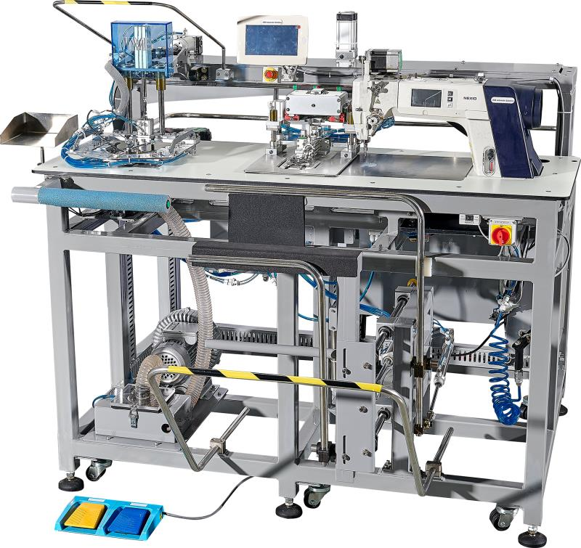

11

12

8

9

5

4

3

2

1

7

6

**1：Machine head； 2：Power switch； 3：Control box； 4：Stacker； 5：Pedal； 6：Suction system； 7：Loader； 8：Pocket loader； 9：Folding group； 10：Touch screen； 11：Activity template organization； 12：presser foot lifting mechanism。**

# 2、Technical parameters of the equipment

|  |  |  |  |  |
| --- | --- | --- | --- | --- |
| MB1002D Chino Pocket Setter | | | | |
| 1 | Machine head | | Brother -1-S7300A-303P | |
| 2 | Maximum sewing speed /rpm | | 2800 | |
| 3 | Table（Optional） | | Compact Laminate | |
| Stainless steel | |
| 4 | Working voltage /V | | 220 | |
| 5 | Working pressure /Mpa | | 0.5 | |
| 6 | Spindle, X/Y control | | AC Servo motor | |
| 7 | Stitch length /mm | | 1--4 | |
| 8 | Working efficiency | | 150 pcs/h | |
| 9 | Way of the mould | | Fast changing mould | |
| 10 | Size/mm | | 2000L×1300W×1550H | |
| 11 | Weight/kg | | 395 | |
| 12 | Needle type | | DB*1 | |
| 13 | Shape |  | Size:mm | Large：140*140--180*180  Middle：95*110--140*140  Small：73*79--95*110 |
|  |
|  |
|  |
|  |
|  |

# 3、Safety precautions

**Considerations for safe use of automata**

|  |  |
| --- | --- |
| 去 | **1. In order to prevent accidents caused by electric shock, please do not open the cover of the electrical box of the motor or touch the parts in the electrical box when the power is connected.** |
| 注意 | **1. In order to prevent personal injury, please do not operate the machine in the state of removing the belt guard, finger protector and other safety devices.**  **2. In order to avoid being involved in the machine's personal accident, please do not let your fingers, hair, clothes near the pulley, v-belt, motor, and do not put items on it during the operation of the sewing machine.**  **3. To prevent personal injury, please do not put your finger near the needle when turning on the power or running the machine.**  **4. In order to prevent personal injury, please do not put your fingers in the wire pole guard during the operation of the sewing machine.**  **5. When the machine is running, it turns at a high speed. To prevent damage to the hand, never let the hand near the cutter during operation. In addition, when changing the cable, please be sure to turn off the power.**  **6. In order to prevent personal injury, please be careful not to pinch your fingers when the machine moves up and down or when you return to the original position.**  **7. Please do not cut off the power or air supply while the machine is running.**  **8. In order to prevent accidents caused by sudden starting, please remove the cloth guide when the preparation work is finished and the sewing state is reached.**  **9. In order to prevent accidents caused by electric shock, please do not operate the sewing machine when the ground wire of the power supply is removed.**  **10. In order to prevent accidents caused by electric shock and damage to electrical parts, be sure to turn off the power switch before inserting or unplugging the power plug.**  **11. In order to prevent accidents caused by damage of electrical parts, please stop the operation for safety when it thunders and pull the power plug.**  **12. In order to prevent accidents caused by damage to electrical parts, condensation will occur when moving from a cold place to a warm place immediately, so please wait until the water drops dry before switching on the power.**  **13. As this product is a precision machine, please pay full attention to it during operation, do not splash water or oil on the machine, and do not let the machine fall and give the machine impact.**  **This machine is A class A industrial machine. The use of this machine in the home environment may cause the phenomenon of radio interference. At this point, please take appropriate measures to solve the problem of radio interference.**  **15. After the power switch is turned off when the accumulator moves, the accumulator lever moves, so please be careful not to clip your finger, etc.**  **16. When the power switch is turned off during the foot press action, please be careful not to pinch your fingers.**  **17. During folding operation, please be careful not to clip the cylinder to your finger when putting your finger into the folding machine.** |

**\* important safety information:**

√ improper operation of the machine may cause personal injury. Please read this instruction carefully and operate correctly before operation.

√Please ventilate the machine before it is officially powered on.

√ do not turn on the internal parts of the electric cabinet or touch screen while the power is on.

√ this machine should be used after receiving training or under special instruction to ensure the safety of the user.

# 4、key function description

## 4.1.Function description of the button

7

5

6

1



4

3

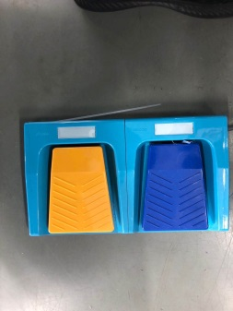

2

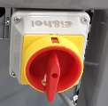

（1）：Headlight source switch -- after turning on, the headlight source is turned on.

（2）：Power switch -- rotate the power switch to ON by -90° to energize and ventilate the equipment.

（3）：Pedal--- After the Yellow pedal on the left side is stepped down, the placed pockets are checked; When the blue pedal on the right side is depressed, the air suction is turned on.

（4）：Sewing switch: after pressing both sides at the same time, the equipment will start sewing.

（5）：Emergency stop button of folding group --- press the button to stop the folding group.

（6）：Sewing emergency stop button - press to stop sewing.

（7）：Touch screen---See《MB1002D interface description》

a：Main interface

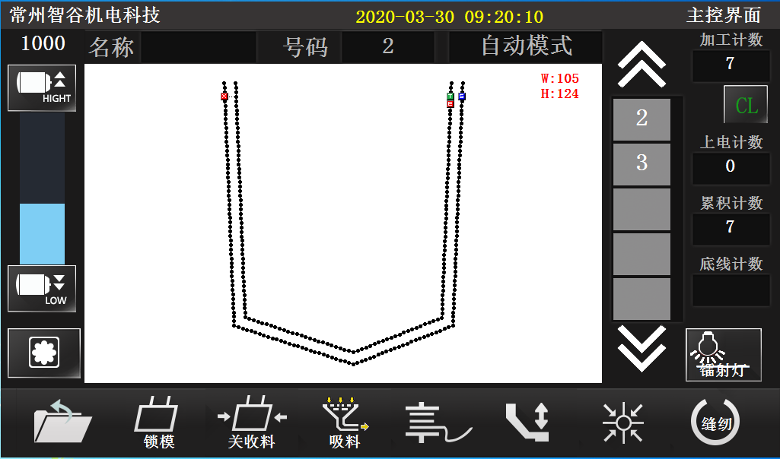

b：Sewing interface

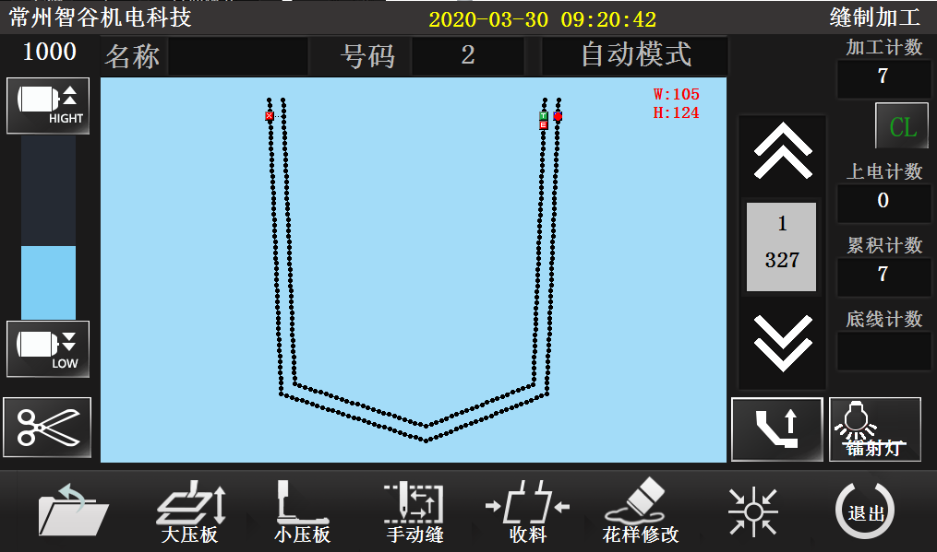

## 4.2.Reset operation instructions

4.2.1 Boot reset operation

|  |  |  |
| --- | --- | --- |
| Steps | Instructions | The key way to |
| 1 | Boot | 4.1（2） |
| 2 | Reset | 4.1（7）--a |
| 3 | Switch sewing mode | 4.1（7）--a  --b |

4.2.2 Emergency stop reset operation

Case 1: emergency stop of folding group, steps of reset: turn the emergency stop switch of folding group clockwise to reset, and the fabric is placed again.

Case two: sewing emergency stop, reset steps: emergency stop switch clockwise rotation reset,

（1）continue sewing：（6）--b-- Back to the sewing point, click “ ” continue sewing；

（2）re-sewing: (6) --b-- reset. 

# 5、Operating instructions

## 5.1. Preparation before operation

√ The machine head shall be in the stop state when the operator checks it

√ Check whether the pressing plate sponge is intact

√ Check whether the sewing thread has been put on correctly

√ Check whether the needle has been installed

√ Clean the sundries on the machine table to ensure that there are no sundries hindering the operation of the machine

√ Check the pressure of the air pressure gauge to make it meet the use requirements of the machine

√ Check whether the eye guard has been installed correctly

## 5.2. Operation process description

5.2.1 Boot device

Rotate the power switch at 90° to the ON position, and the equipment will be powered ON.

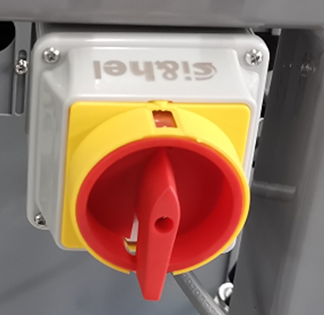

5.2.2 Reset operation

Perform the machine power on reset operation. Please refer to: 4.1. Key function description -- 4.2.1 power on reset operation. The following figure shows the status of the device after the reset.

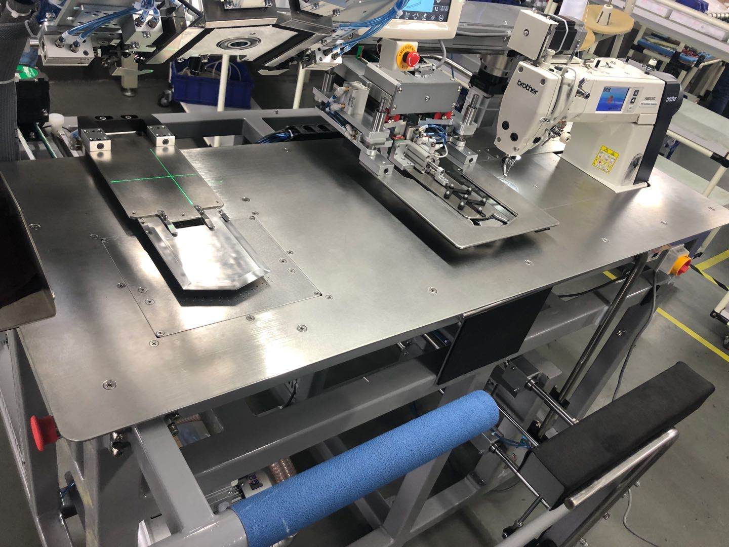

Center blade

**\*** **NOTICE：**

**A:Pedal mode**

**If the center blade is retracted, the machine is in pedal mode. At this time, step on the pedal continuously, extend the center blade, and open the air suction**

**B:Automatic mode**

**If the center blade is extended, suction is on. The machine is in automatic mode**

5.2.3 Fabric placement

Align accurately according to the laser spotlight, and place the back parts as shown in the figure below.

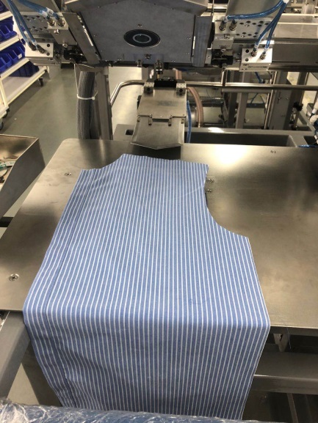 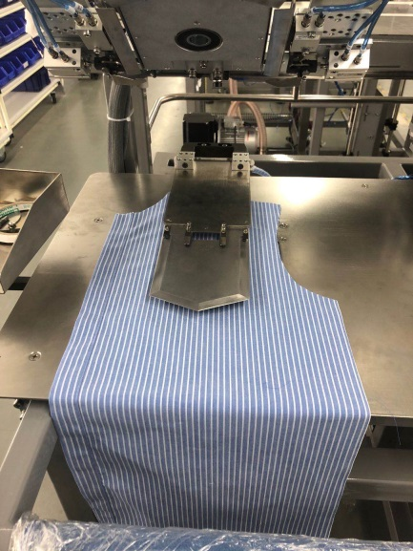

**Pedal mode** **Automatic mode**

5.2.4 Pocket palcement

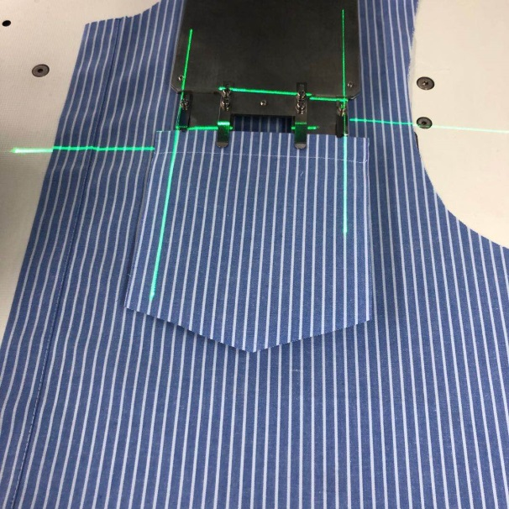

As shown on the right

Auto mode

As shown on the right

Suction on

Center blade extend

Press the right blue pedal

Pedal mode

**\*When placing the pocket, check the strip if necessary: press the Yellow pedal on the left side, the pocket template will descend to the table top, and check the strip, as shown in the following figure:**

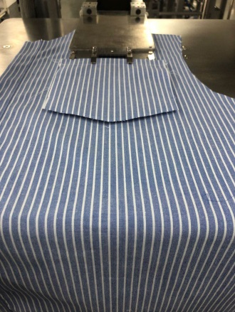

5.2.5 Automatic folding and sewing

1. Press the 4.1 (4) sewing switch, and the folding group will press down the automatic folding; see figure (a)

2. The folding is completed, as shown in figure (b) below. The center blade is pressed down together with the folding group, and the folding group is restored to its original position. After the cloth feeding plate is moved to the left over the center blade, it is pressed down to press the pocket, and the center blade is withdrawn backward, and the cloth feeding plate is moved to the right to start sewing, as shown in figure (c) below.

3. After sewing, the material will be automatically received, as shown in figure (d), and the cloth feeding plate will return to the original point.

**\*** **Move the cloth feeding plate to the right of the sewing area, and continue to place the fabric on the left side, and operate in turn.**

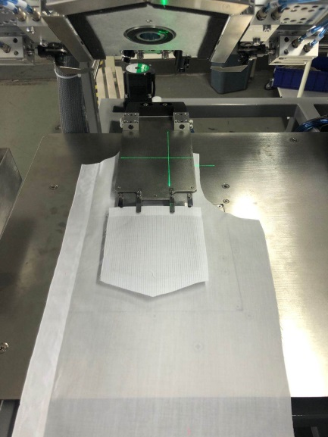 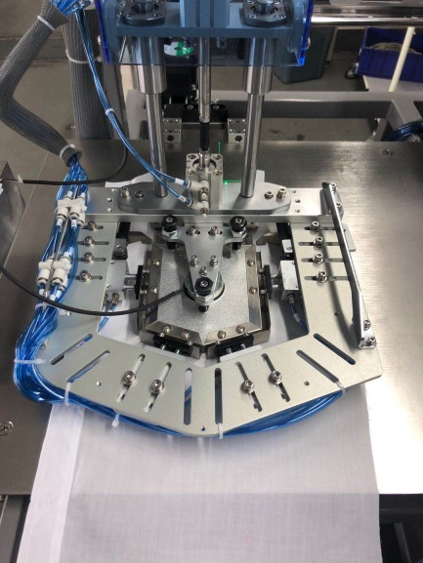

a b 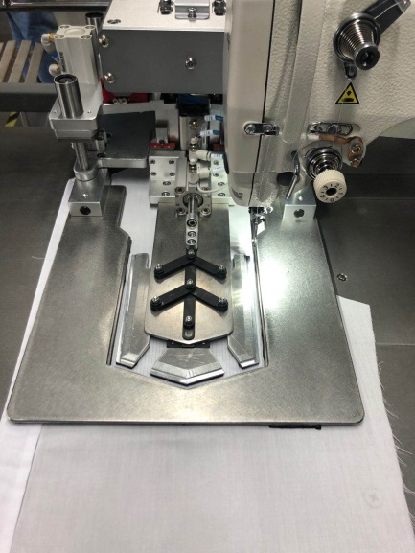 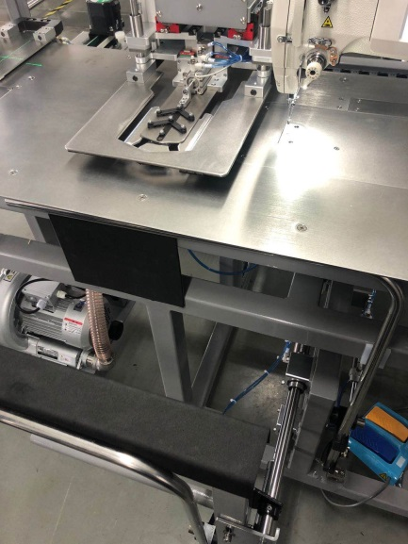

Feeding plate

c d

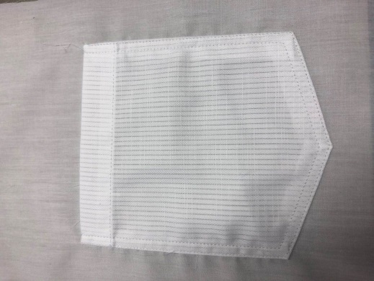

Sewing sample

5.2.6 Shutdown

After operation, turn the power switch 90 ° to the off position, and the equipment will be shut down.

# 6、Debugging method

## 6.1 Jig position



**Activity template**

Folding group

Folding clamp

Feeding plate

Center blade

Suction plate

## 6. 2 Jig changing procedure

6.2.1 Dismantling jig

Disassembly and assembly of the mould shall be carried out as follows:：

Disassembly and assembly of cloth feeding plate and center blade：Touch screen 4.1（7）a“”，Unlock the mould cylinder, and directly remove the cloth feeding plate and center blade as shown in the figure below:

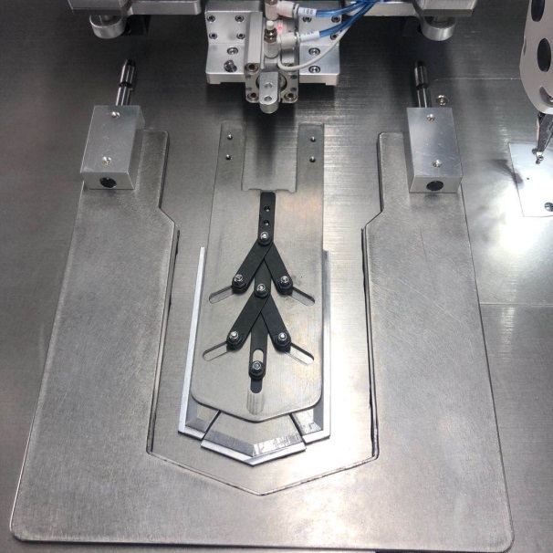 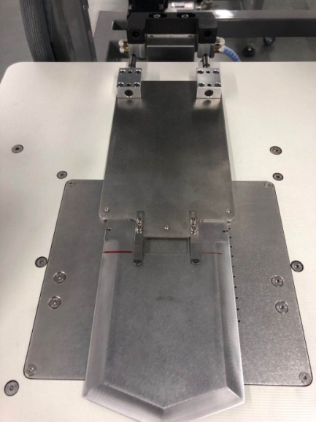

screw

1. Disassembly and assembly of folding group： First, turn off the 4.1 (2) power switch, and the equipment will enter the shutdown state, as shown in the following figure

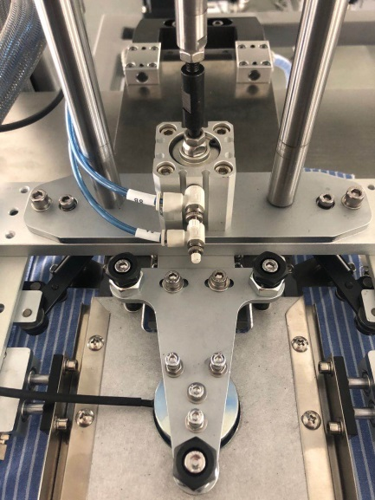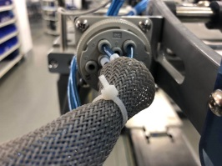 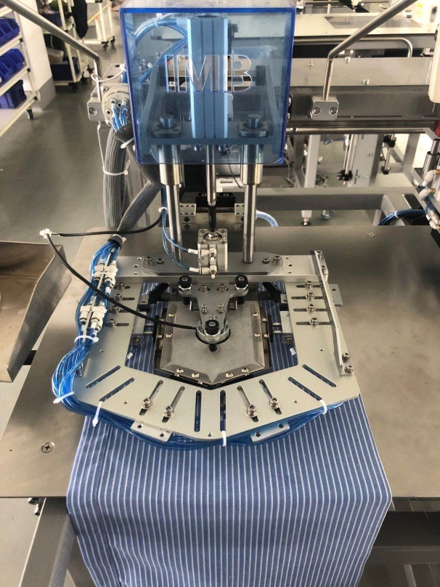

Folding group

Joint

Screw

At this time, the whole folding group can be removed by removing the screw and the joint.

1. Remove the air suction cover plate: remove the screws a and B in the figure below, and then remove the air suction cover plate。

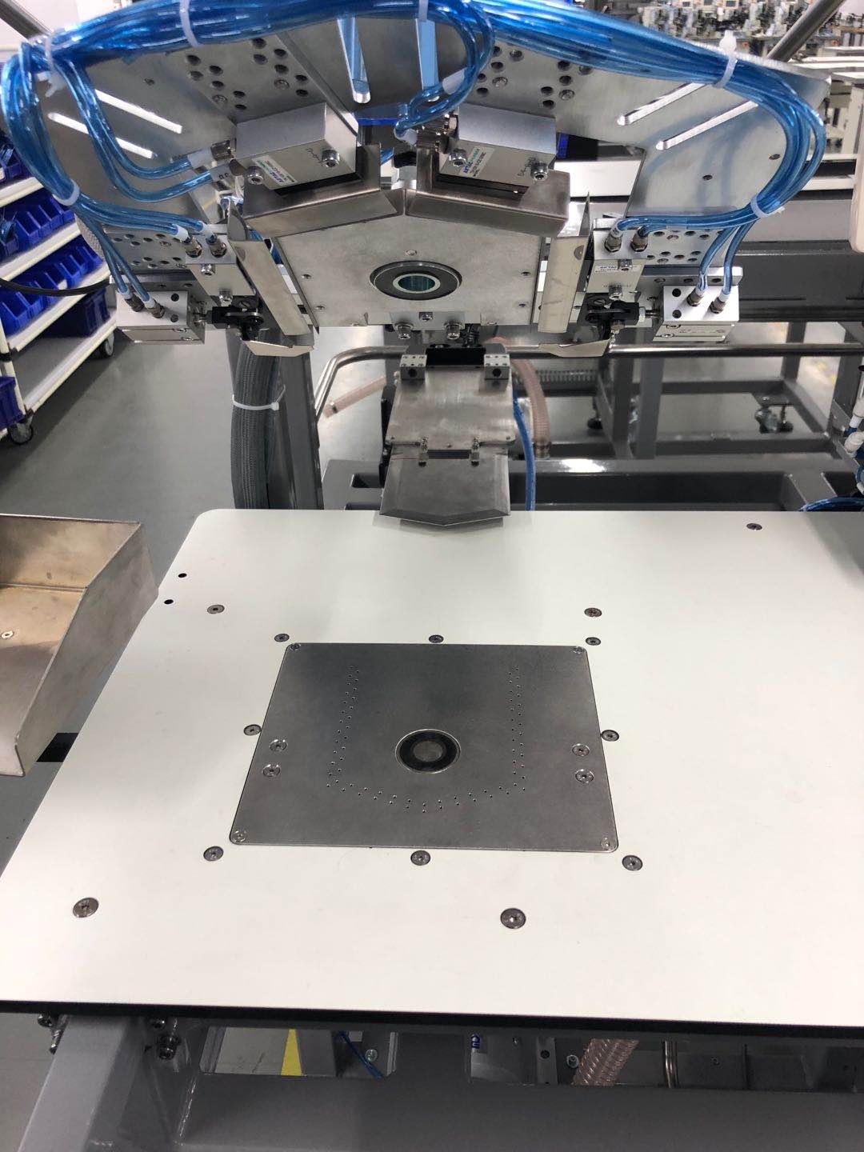

b

b

a

a

a

a

a： 4-M4*8

b： 4-M5*8

\***\*Pay attention to the order of mold removal: 1. Remove the center blade and cloth feeding plate - 2. Remove the folding group - 3. Remove the air suction cover plate. The installation sequence is the reverse of the removal sequence**

6.2.2 Equipment debugging and parameter setting

**Equipment debugging shall be carried out as follows**

6.2.2.1 Horizontal debugging of cloth feeding board

Press 4.1（7）a “” Enter the following interface：：

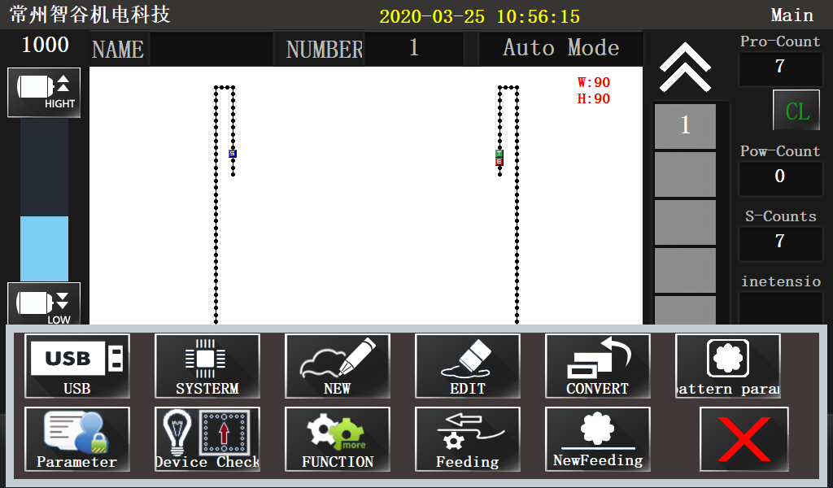

Click“”，Enter the equipment detection interface, as shown below:

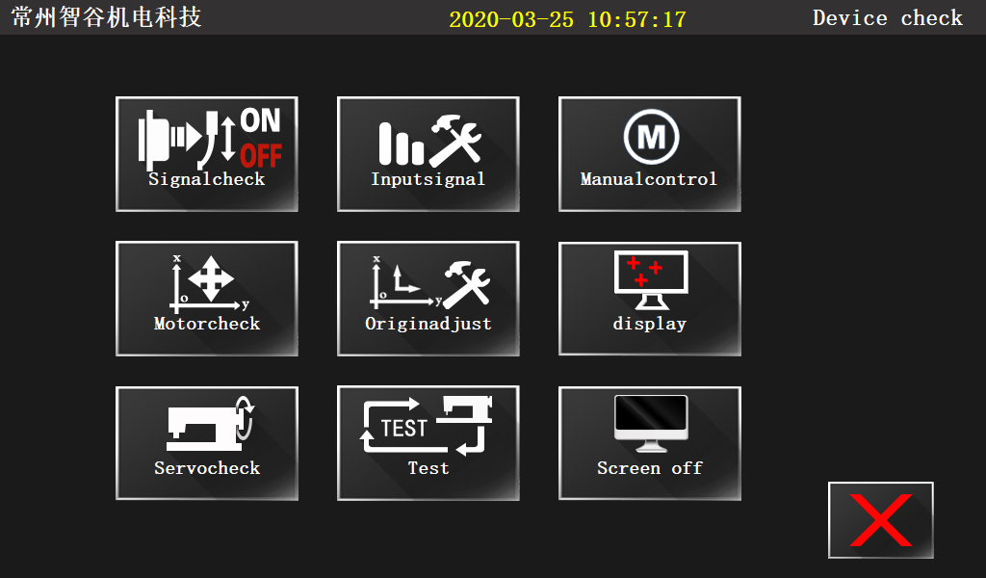

Click“” Enter the step motor detection interface, as shown in the following figure;

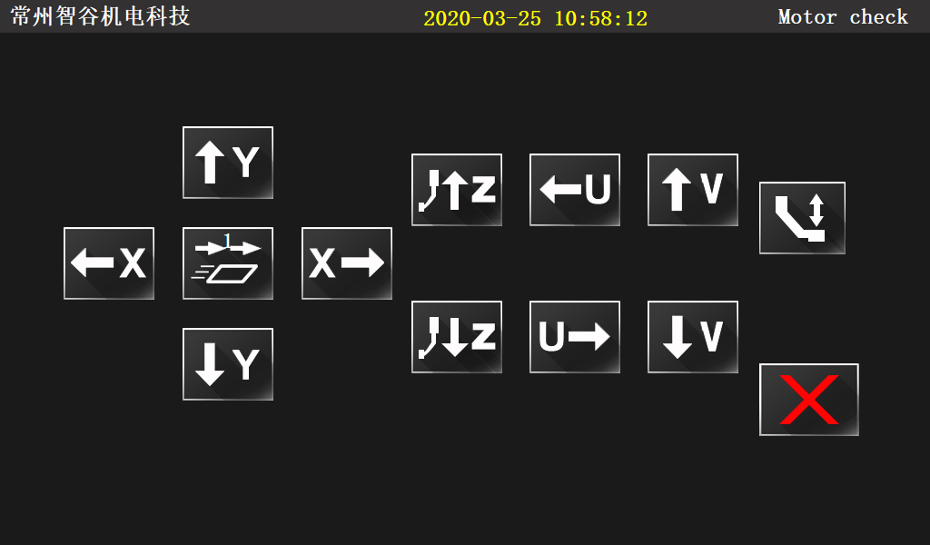

Press“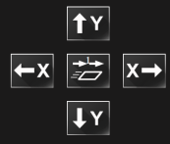” Move the position of the cloth feeding plate as shown in Figure A. confirm the horizontal and vertical position of the cloth feeding plate by taking the needle as the reference. If the position of the cloth feeding plate cannot meet the requirements of the equipment, adjust the position of the cloth feeding plate by the screw in Figure B.

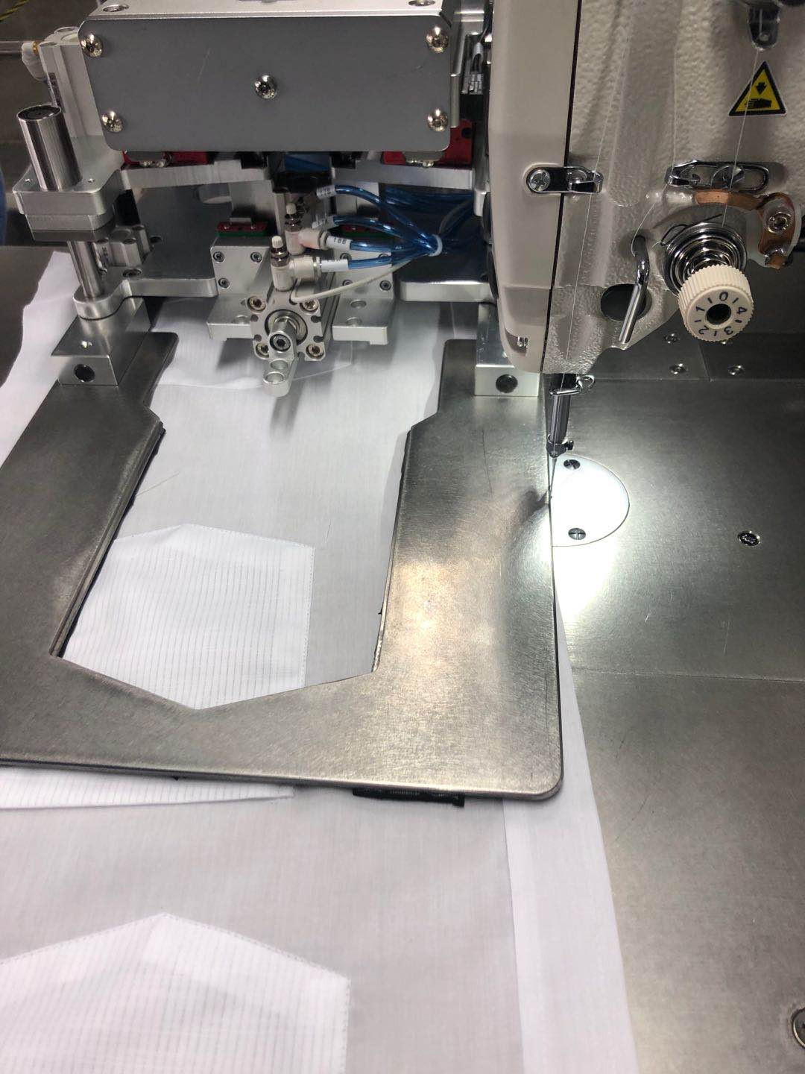 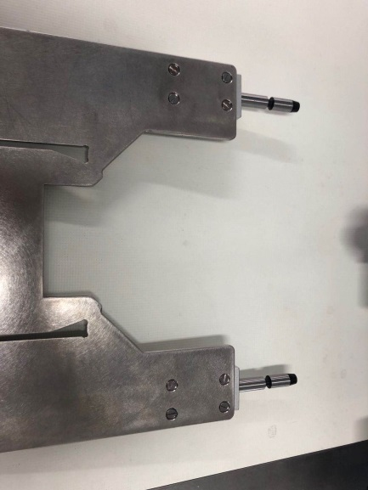

screw

a b

6.2.2.2 Parameter setting

Press 4.1（7）--Main interface a-- --  go to the following interface and input the required size, press“”to save

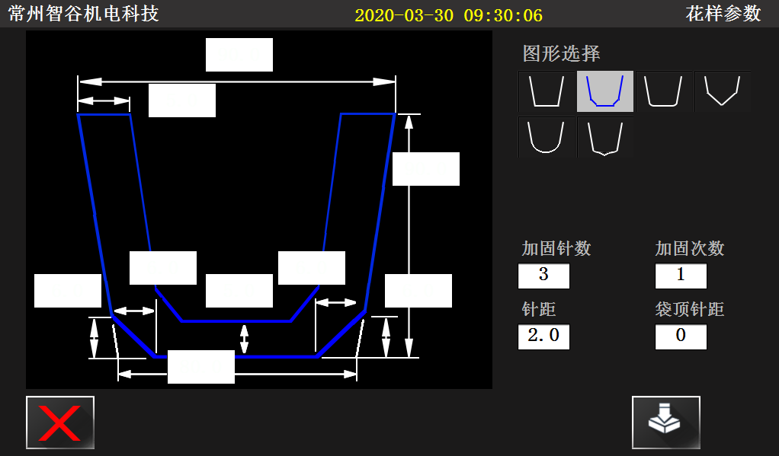

6.2.2.3 Adjust mold 1 or 2

Touch screen 4.1（7）--Main interface a-- to the following interface：

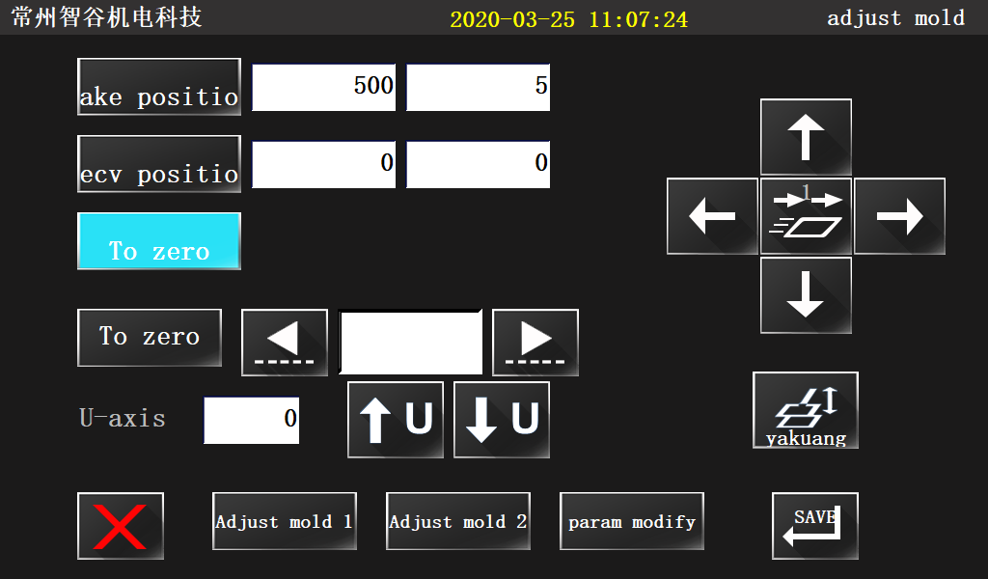

Press“ ”or“ ”，Move the cloth feeding plate to the position shown below，Move the cloth feeding plate through “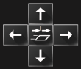” to confirm the position matching between the cloth feeding plate and the needle, and click after matching“ ”。

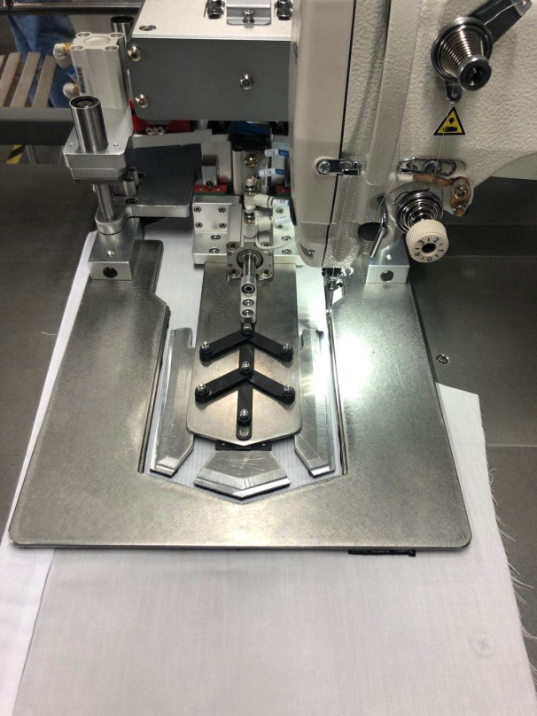

6.2.2.4 Picking position debugging

Click“ ” ，a Press“”、“” Adjust the front and rear positions (U-axis position) of the center blade to match the center blade with the air suction cover plate, as shown in the following figure:

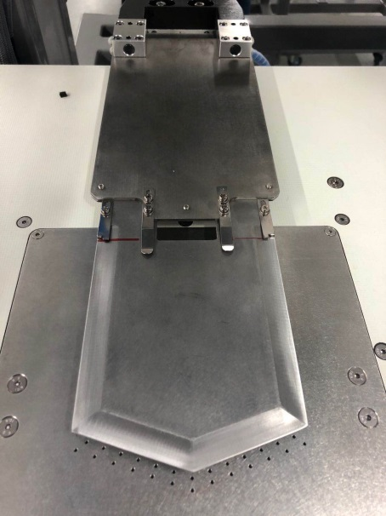

B Press“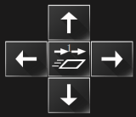” Adjust the position of the cloth feeding plate, move it to the top of the center blade as shown in the figure below, and start to align the center blade, so that the cloth feeding plate is consistent with the center blade, Press“”，Press the cloth feeding plate down, and then confirm whether the cloth feeding plate is consistent with the center blade, Click“ ” after debugging，Return the cloth feeding plate and center blade to the position.

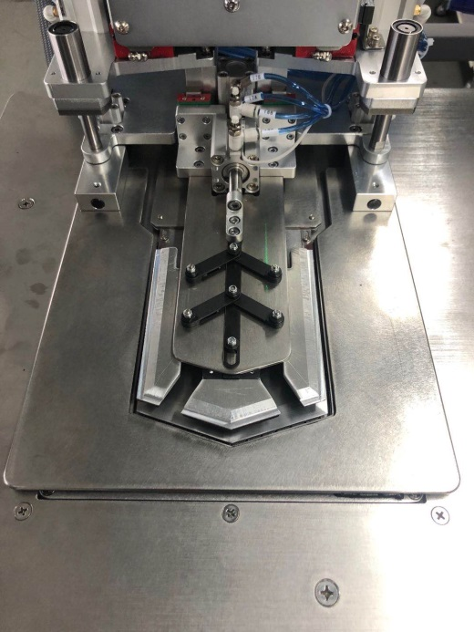

6.2.2.5 Folding group debugging

Press“”，then press“”、“” Adjust the equipment steps, check the position of the formwork and the folding effect

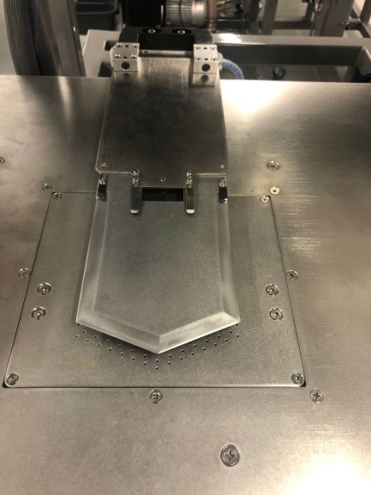 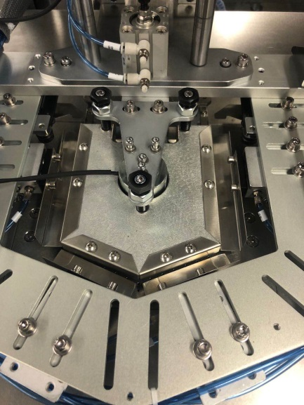 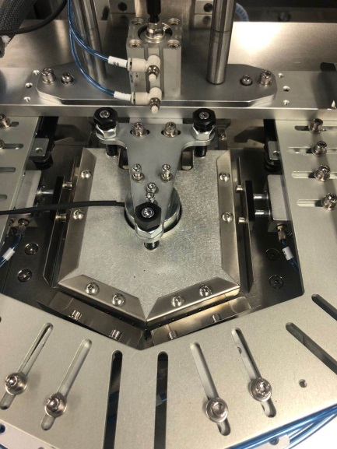

Clamp1

1 Step 2 Step 3 Step

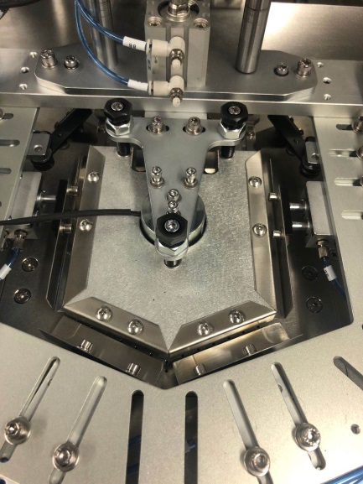 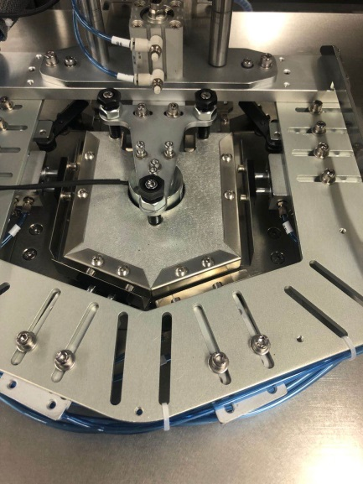 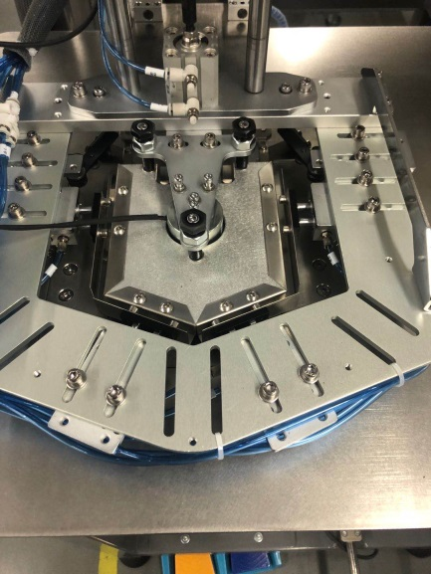

Clamp4

Clamp3

Clamp2

4 Step 5 Step 6 Step

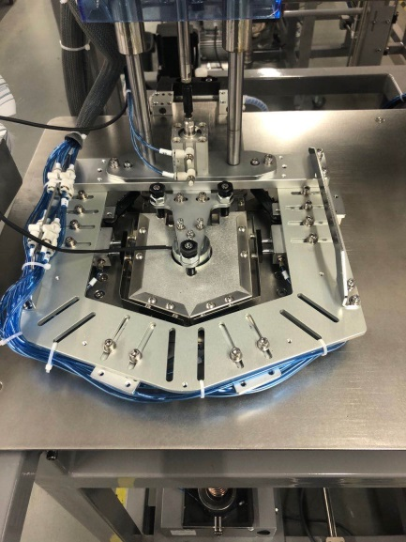 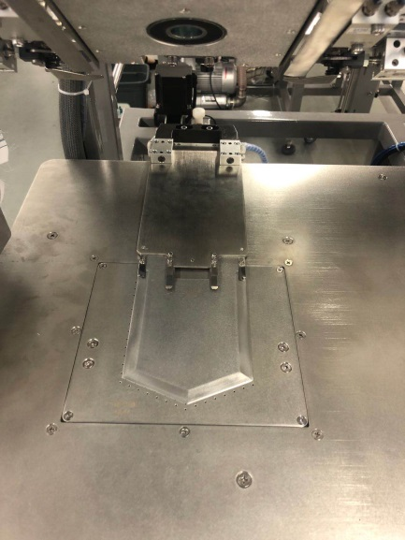 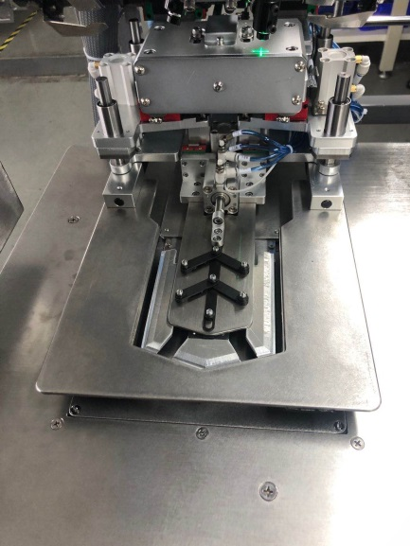

7 Step 8 Step 9 Step

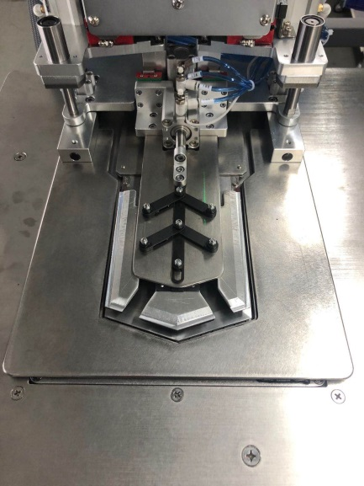 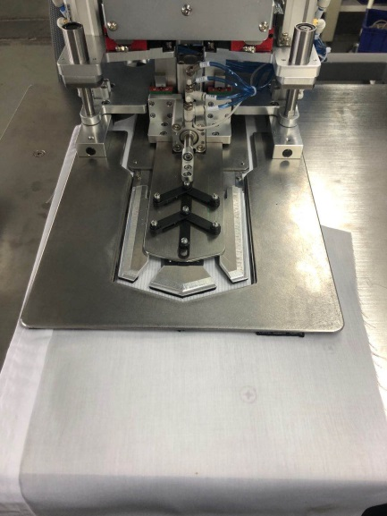 

10Step 11 Step 12 Step

**1step：Center blade extend。（Press**“”、“”**to make fine adjustments）**

**2step：Press down the folding group, and adjust the position of the folding group through the adjusting screw of the folding group in the figure below, so that the folding group matches the center blade。**

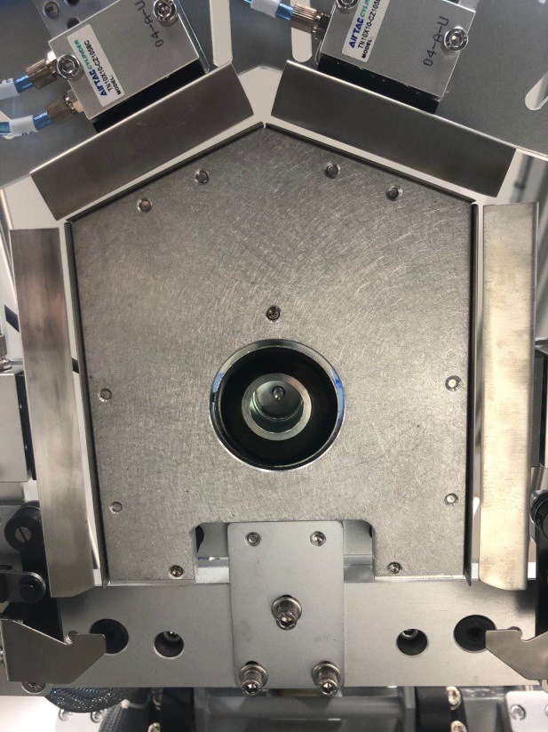

screw

**3step：Clamp 1 extend。**

**4step：Clamp 2 extend。**

**5step：Clamp 3 extend。**

**6step：Clamp 4 extend。**

**\*3~6step：The folding position can be adjusted by the screw in the figure below to make the folded pocket meet the requirements.**

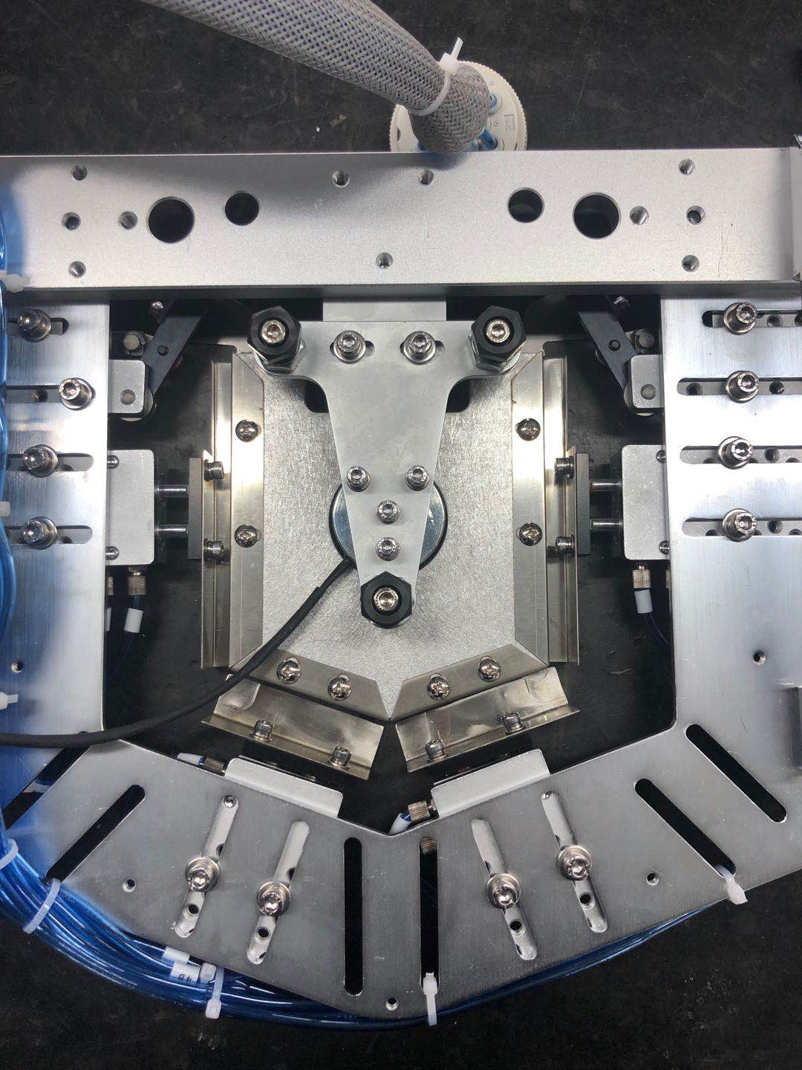

screw

**7step：Press down the folding group and center blade to the table top。**

**8step：The clamp of the folding group is restored to its original position, and the folding group is lifted to its original position。**

**9step：Move the cloth feeding plate to the left over the center blade（press**“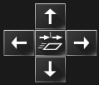” **to make fine adjustments）。**

**10step：Cloth feeding plate press down。**

**11step：The center blade is withdrawn from the origin, and the cloth feeding plate is moved to the right.。**

**12step：Long press or tap “”、“”，Or press the sewing switch to start the test sewing.。**

**\*** **During the first commissioning, sponge shall be pasted on the pocket folding mold and cloth feeding board, as shown in the following figure (a, b). After the first sewing, sponge channel shall be widened along the sewing route, as shown in Figure C.**

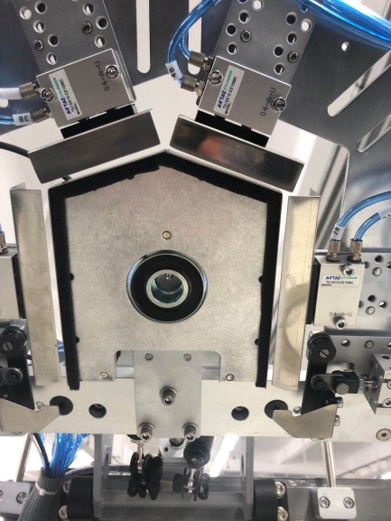 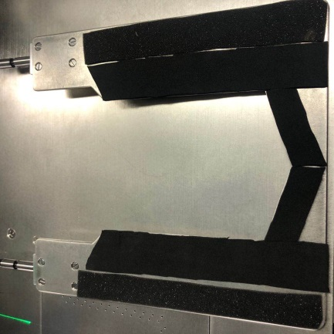 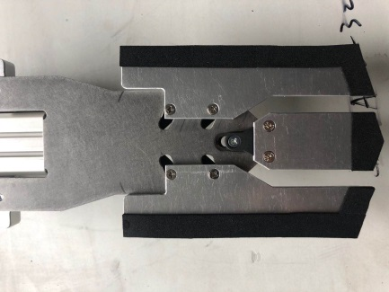 a b c

**\*** **The electromagnet needs to protrude 1 ~ 3mm from the pocket folding die, as shown in the figure below：**

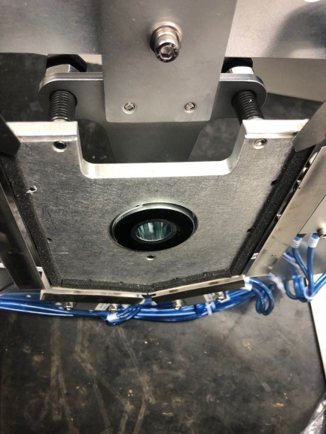

**\*\*** **The distance a between the electromagnetic hanging plate and the pocket folding die shall be 18 ~ 20mm, as shown in the figure below：**

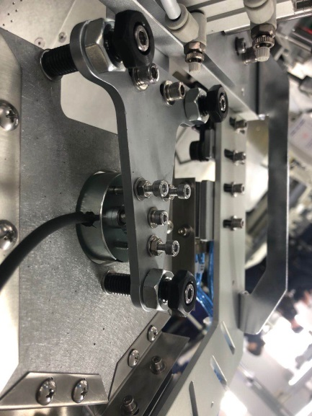

**A**

**\*** **When adjusting the height of the cloth feeding plate, the cylinder shaft can be lifted through the following figure, and the upper and lower adjustment range is 2mm：**

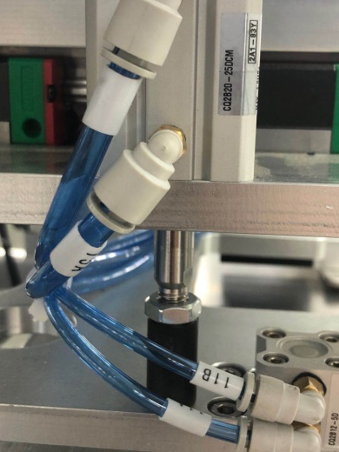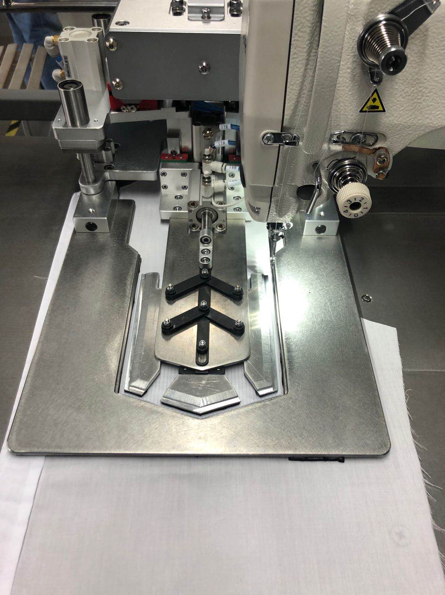

cylinder shaft

# 7、Electrical wiring

## 7.1. Signal board：

|  |  |  |  |  |  |
| --- | --- | --- | --- | --- | --- |
| MB1002B | PORT | NORM | CABLE NO | TO ZERO | REMARK |
| X Origin | IN1 | 1X3 | 1X3 |  |  |
| Y Origin | IN2 | 1X3 | 1X3 |  |  |
| Z Origin | IN3 | 1X3 | 1X3 |  |  |
| U Origin | IN4 | 1X3 | 1X3 |  |  |
| Folding down | IN5 | 1X3 | 1x2 |  |  |
| Spare | IN6 | 1X3 | 1X3 |  |  |
| Y2 Limit | IN7 | 1X3 | 1X3 |  |  |
| Pedal | IN8 | 1X3 | 1X3 |  |  |
| Spare | IN9 | 1X3 | 1X3 |  |  |
| Folding up | IN10 | 1X3 | 1x2 |  |  |
| Flip down | IN11 | 1X3 | 1x2 |  |  |
| Pressing clamp up | IN12 | 1X3 | 1x3 |  |  |
| (Break detection)24V | IN13 | 1X3 | 1x3 |  |  |
| Center blade 1 | IN14 | 1X3 | 1x2 |  |  |
| Pressing clamp down | IN15 | 1X3 | 1X3 |  |  |
| Pressure detector | IN16 | 1X3 | 1x2 |  |  |
| Pedal 2 | IN17 | 1X3 | 1x2 |  |  |
| Manual sewing | IN18 | 1X3 | 1x2 |  |  |
| Cycle sewing | IN19 | 1X3 | 1x2 |  |  |
| Spare | IN20 | 1X3 | 1x2 |  |  |
| Sewing stop | IN21 | 1X3 | 1x2 |  |  |
| Folding stop | IN22 | 1X3 | 1x2 |  |  |
| Spare | IN23 | 1X3 | 1x2 |  |  |
| Spare | IN24 | 1X3 | 1x2 |  |  |
| Spare | IN25 | 1X3 | 1x2 |  |  |
| Spare | IN26 | 1X3 | 1x2 |  |  |
| Spare | IN27 | 1X3 | 1x2 |  |  |
| Spare | IN28 | 1X3 | 1x2 |  |  |
| X axis alarm | Board | JK2 | 1X3 |  | 2 Public ground, direct docking |
| Y axis alarm | Board | JK2 | 1x2 |  |
| Break detection 5V | Board | J6/4 | 1x2 |  | 3 -5V  1 +5V  2 NONE |
| Spare | Board | J6/5 | 1x2 |  |
| Spare | Board | J6/6 | 1x2 |  |

## 7.2 Expansion board electromagnetic valve

|  |  |  |  |  |
| --- | --- | --- | --- | --- |
| MB1002B | PORT NO |  | TO ZERO SWITCH | REMARK(METER) |
| Stacker 2 | J1 | Solenoid | OFF | 76 |
| Center blade 2 | J2 | Solenoid | OFF | 52 |
| Center blade | J3 | Solenoid | OFF | 53 |
| Folding 1 | J4 | Solenoid | OFF | 54 |
| Folding 2 | J5 | Solenoid | OFF | 55 |
| Folding 3 | J6 | Solenoid | OFF | 56 |
| Thread clamp | J7 | Solenoid | OFF | 51 |
| Outer clamp | J8 | Solenoid | ON | 72 |
| Out89 | J9 | Solenoid | OFF | 89 |
| Out90 | J10 | Solenoid | OFF | 90 |
| Stacker 3 | J11 | Solenoid | OFF | 61 |
| Out91 | J12 | Solenoid | OFF | 91 |
| Stacker 1 | J13 | Solenoid | OFF | 60 |
| Suction | J14 | Solenoid | OFF | 62 |
| Folding group 1 | J15 | Solenoid | OFF | 65 |
| Folding group 2 | J16 | Solenoid | OFF | 59 |
| Folding 4 | J17 | Solenoid |  | 57 |
| Suction2 | J18 | Solenoid |  | 67 |
| Mould | J19 | Solenoid |  | 92 |
| Suction motor | J20 | Solenoid |  | 68 |
| Clamping die | J21 | Solenoid |  | 69 |
| Outer clamp 2 | J22 | Solenoid |  | 70 |
| Thread wiper | J23 | Solenoid |  | 78 |
| Out83 | J24 | Solenoid |  | 83 |
| Folding group 3 | J25 | Solenoid |  | 63 |
| Folding group 4 | J26 | Solenoid |  | 64 |
| Secondary folding | J27 | Solenoid |  | 66 |
| Out93 | J28 | Solenoid |  | 93 |
| Out94 | J29 | Solenoid |  | 94 |
| Out84 | J30 | Solenoid |  | 84 |
| Out85 | J31 | Solenoid |  | 85 |
| Out86 | J32 | Solenoid |  | 86 |
| Out79 | J33 | Solenoid |  | 79 |
| Out95 | J34 | Solenoid |  | 95 |
| Out96 | J35 | Solenoid |  | 96 |
| Out97 | J36 | Solenoid |  | 97 |
| Out87 | J37 | Solenoid |  | 87 |
| Out88 | J38 | Solenoid |  | 88 |
| Laser 1 | J51 | 5V |  | 81 |
| Laser 2 | J52 | 5V |  | 82 |
| Laser 3 | J53 | 5V |  | 98 |
| Laser 4 | J54 | 5V |  | 99 |
| Inner clamp | JC1 | electromagnet |  | 58 |
| Presser foot | JC2 | electromagnet |  | 77 |
| Trimmer | JC3 | electromagnet |  | 73 |
| Inner clamp 1 | JC4 | electromagnet |  | 74 |
| Upper suction | JC5 | electromagnet |  | 71 |
| Lower suction | JC6 | electromagnet |  | 75 |

# 8、Optional device

1、There are two types of table to choose：

a Compact laminate table is suitable for small area of environmental humidity

b Stainless steel table is suitable for areas with high environmental humidity

See《MB1002D Parts Manual》

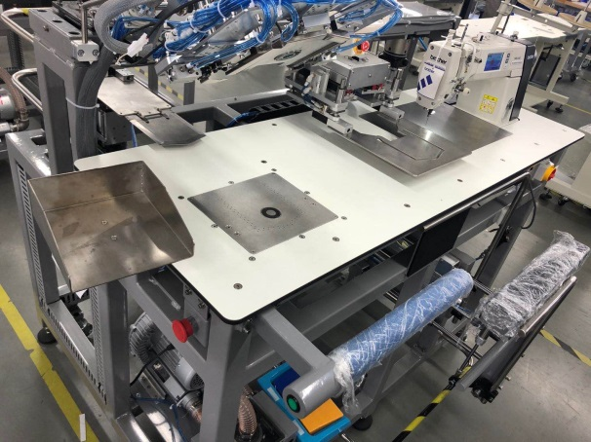 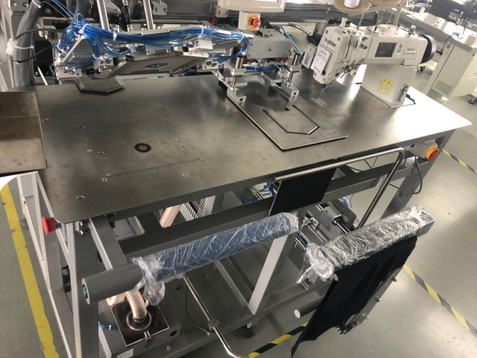

Compact laminate table Stainless steel table

2、Table extension mechanism, suitable for large pieces of clothing，See《MB1002D Parts Manual》

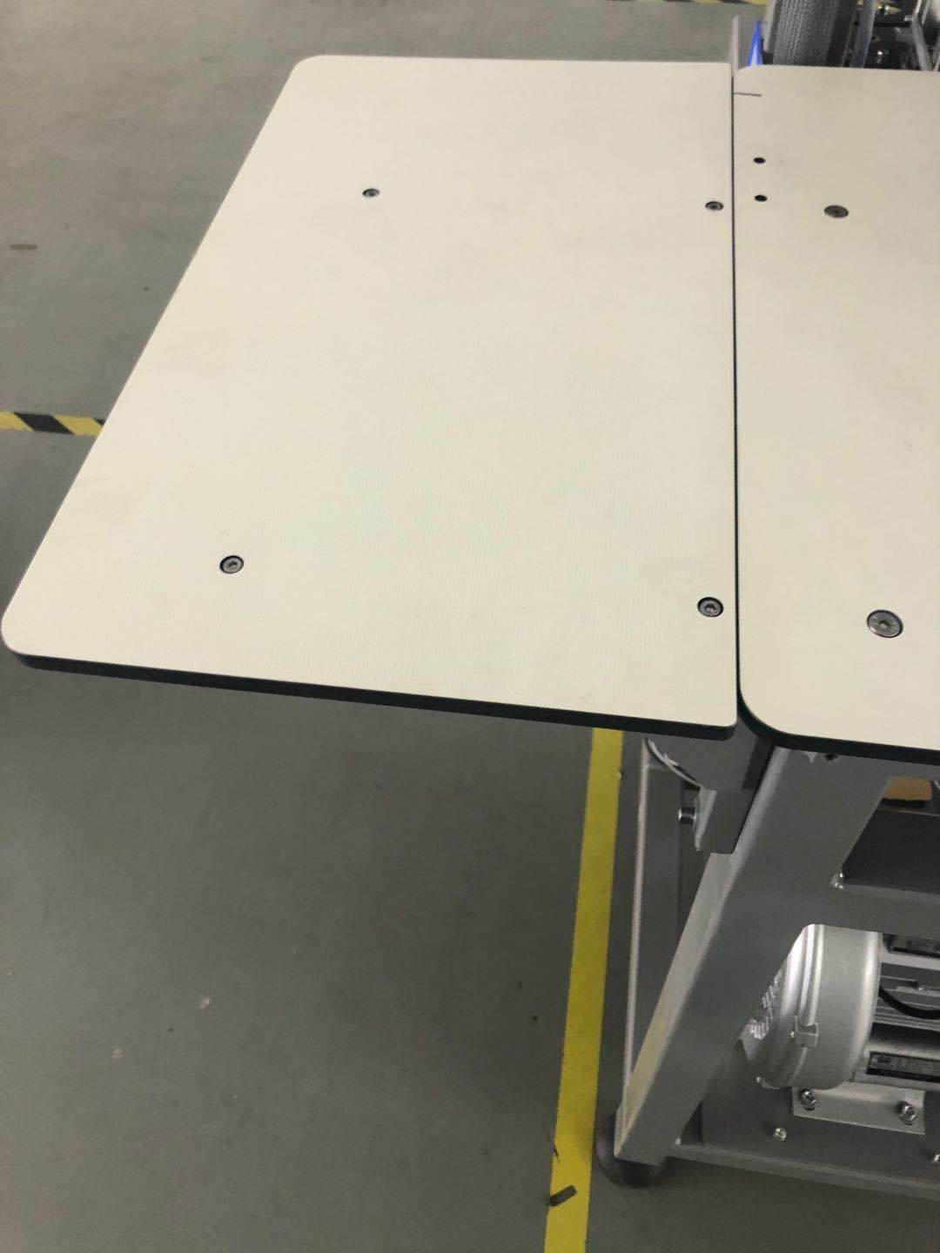

# 9、Accessories box details

|  |  |  |  |
| --- | --- | --- | --- |
| NO | ITEM |  | QTY |
| 1 | 《Instruction manual》 |  | 1 |
| 2 | 《Parts Manual》 |  | 1 |
| 3 | 《Touch screen interface operation instructions》 |  | 1 |
| 4 | Thread stand |  | 1 |
| 5 | Bushing |  | 1 |
| 6 | Bobbin |  | 1 |
| 7 | Sponge mats |  |  |
| 8 | Non-slip leather |  |  |
| 9 | Wrench |  | 1 |
| 10 | Slotted screwdriver |  | 1 |

# 10、**Common problems and Solutions**

10.1. See the table below for common problems and Solutions

10.2. More questions，See《MB1002B Touch screen interface operation instructions》

|  |  |  |  |
| --- | --- | --- | --- |
| Fault phenomenon | Image | Cause Analysis | Solutions |
| Thread break / jumper | / | 1：Needle roughness；  2：The hook distance is too large or too small; | 1. Replace the needle； 2. Adjust the correct hook line distance ； |
| Poor edge |  | 1：Pattern issue；  2 ：The picking position is incorrect;  3：Fabric is not compacted。 | 1. Modified pattern； 2. Adjust the picking position； 3. Adjust the feeding plate pressure。 |
| Fabric wrinkle |  | 1：Feeding plate pressure is too low；  2：Needle or needle plate size is incorrect;  3：Stitches are too tight； | 1. Adjust the appropriate pressure of the feed plate；  2. Replace the needle and needle plate with the appropriate size；  3. Adjust stitch； |
| Poor conner |  | Clamp 2 location is inaccurate | Adjust clamp2  Clamp2 |

# 11、Daily maintenance requirements

11.1. See the following table for the list and requirements of equipment maintenance

11.2. Please refer to brother 1-s7300a-303p for other maintenance requirements

|  |  |  |  |  |  |  |
| --- | --- | --- | --- | --- | --- | --- |
| NO | Project | Frequency | | | | Requirement |
| Daily | Weekly | Monthly | Half year |
| 1 | Clean up the dust | √ |  |  |  | Remove dust from equipment surface and parts |
| 2 | Cleaning up oil pollution |  | √ |  |  | Clean the greasy dirt on the table , needle plate and bobbin |
| 3 | Fan filter |  | √ |  |  | Clean the fan filter dust |
| 4 | Clamp sponge |  | √ |  |  | Check whether the sponge is worn and deformed and needs to be replaced if damaged |
| 5 | Folding group |  |  | √ |  | Keep level and check screw tightening |
| 6 | Center blade |  |  | √ |  | Keep level and check screw tightening |
| 7 | Cloth feeding board |  |  | √ |  | Keep level and check screw tightening |
| 8 | Air tube interface |  |  | √ |  | The air tube interface is tight without air leakage |
| 9 | Oil |  |  | √ |  | Oil volume not lower than warning line |
| 10 | Bobbin |  |  | √ |  | Check if the bobbin is scratched |
| 11 | Sensor |  |  |  | √ | Check if the sensitivity is accurate and if the position changes |
| 12 | Slider |  |  |  | √ | Check slide lubrication and add lubricant if necessary |
| 13 | Electric control box |  |  |  | √ | Cooling fan runs normally, clean up the dust in time |

# 12、Knowledge product protection statement

MB1002B Shirts pocket setter was designed by Changzhou wisdom & valley Electric Technology Co., Ltd.。The intellectual property rights of this achievement belong to Changzhou wisdom & valley Electric Technology Co., Ltd. and are protected by national intellectual property laws and regulations. Without the written permission of the right holder, the patented technology of the achievement shall not be implemented, and the information related to the achievement shall not be copied, sold or disseminated through the network. For any illegal infringement, Changzhou wisdom & valley Electric Technology Co., Ltd. will pursue its legal responsibility according to law.